**Git and GitHub**

It is the most popular VCS. Essentially, version control is software that helps track and manage changes to a set of files over time.

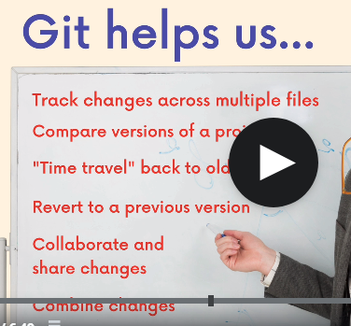

Check points

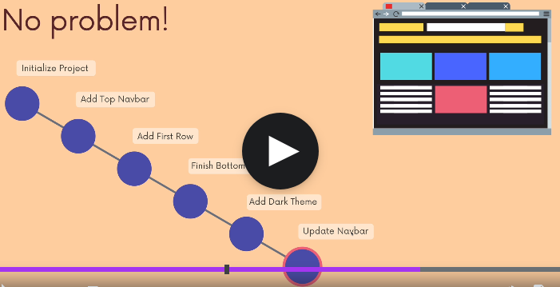

History of Git

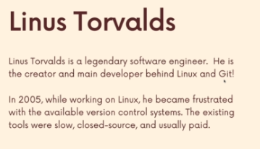

Who uses Git?

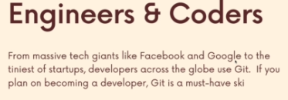

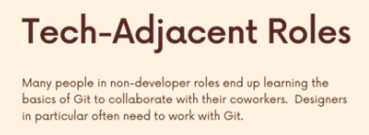

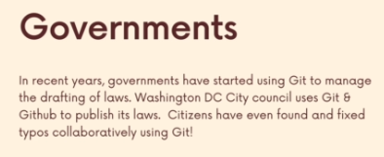

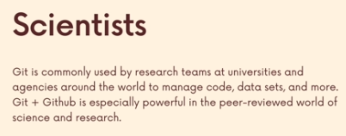

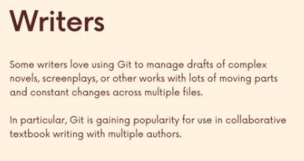

Git vs GitHub

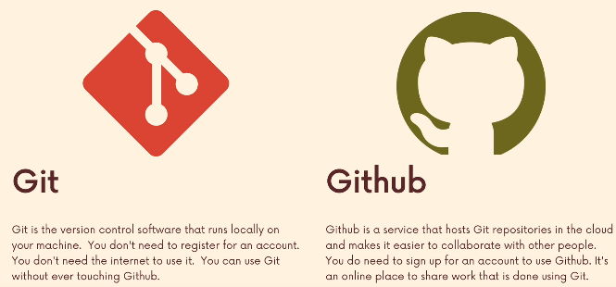

**Installation and set up**

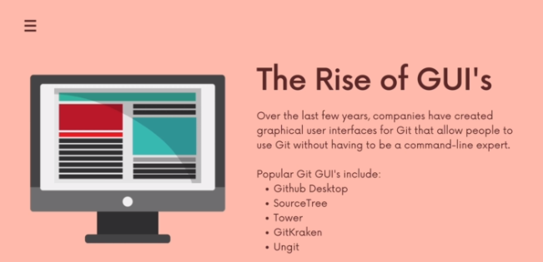

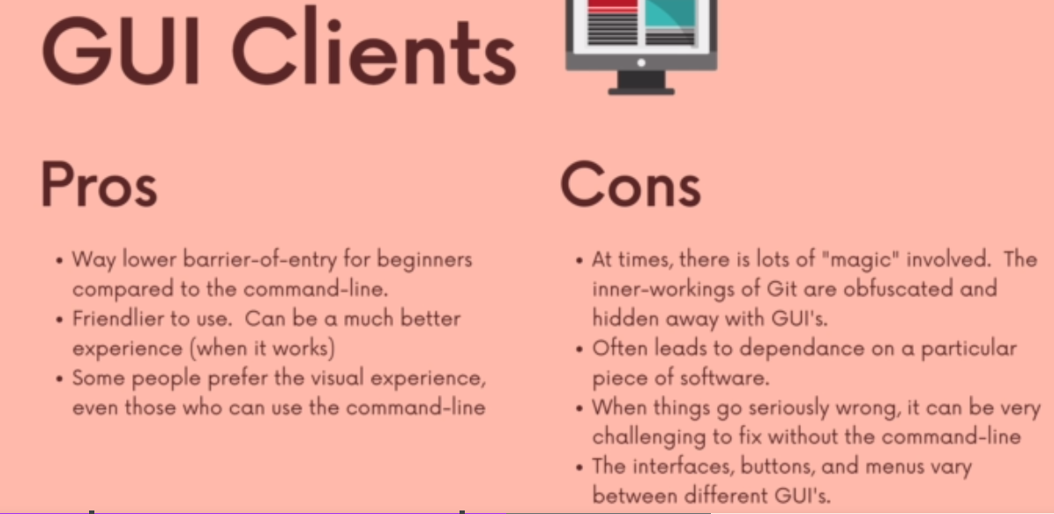

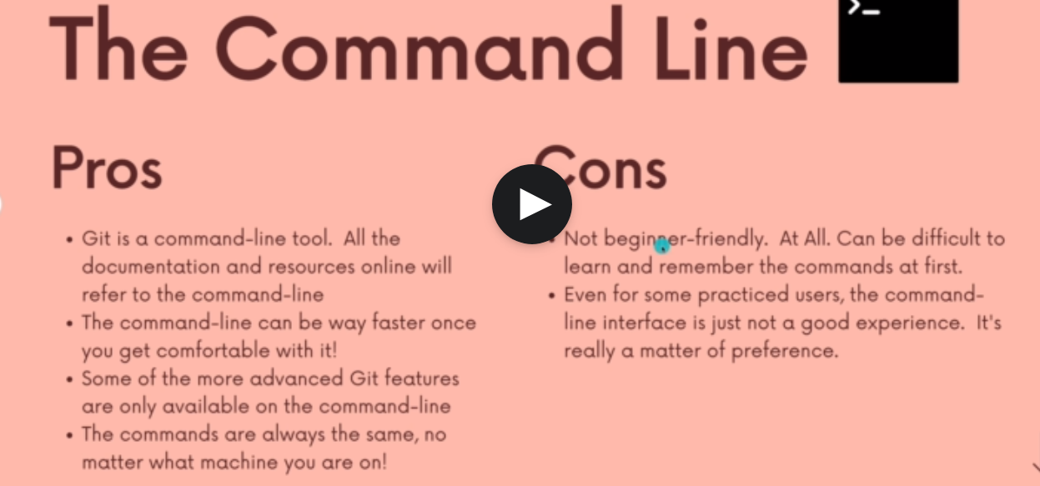

**Installation on Windows**

The problem that we run into on a Windows machine is that Windows machines don't come with a Unix based prompt by default.

Windows comes with a different command line interface called command prompt.

It's not Unix based.

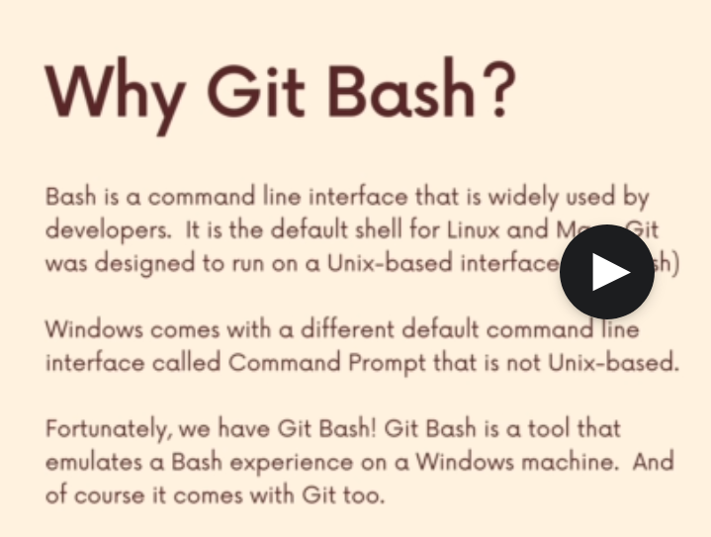

**Configuring name and email**

We should tell that git who we are. Who it should attribute work to on our machine?

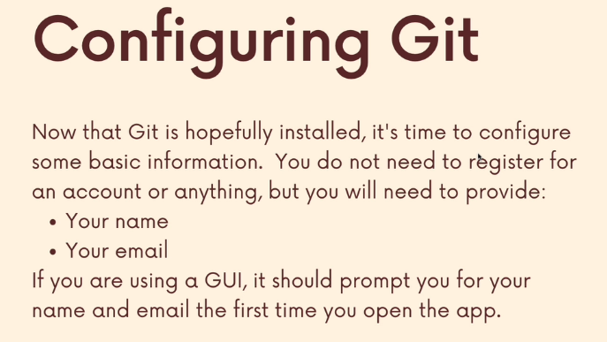

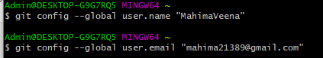



**Installing Git Kraken**

**Terminal Crash course**

Navigation:



For a Mac machine,

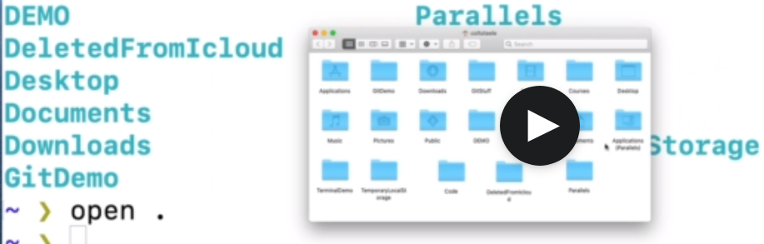

* For windows machine

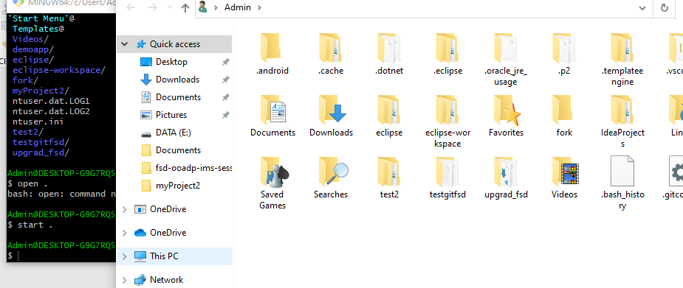

start . command opens up the window for navigation.

Too see what is present in “Documents”

ls Documents

* pwd for printing the working directory
* cd for change directory.
* cd .. to move backwards

**Creating files and folders**

Touch command is used to create file





To create new folders:

mkdir plants

mkdir a.txt b.txt

**Deleting folders and files**

rm <filename>

This deletes the file permanently.

rm a.txt

* To delete folder,

rm -rf <foldername>

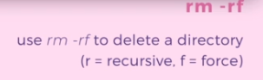

**Basics of Git – Adding and Commiting**

What is Git Repo?